|  |  |
| --- | --- |
| Lewisham young Mayor Overview  Young Mayor 2017/18, Laurelle Henry and Deputy Young Mayor, Edafese Erhenede  Lewish square mono-hi | **What We Do and Why We Do It.**  Malcolm Ball and Katy Brown, Advisors to the Young Mayor  May 2018 |

Table of Contents

Introduction 3

Young Mayor and Young Advisors Work Areas: October 2016 - October 2017 4

Young Mayor Budget Priorities 2016/17 11

Youth Participation and Engagement: why the Young Mayor Model? 12

Evaluation 15

Appendix 1: Comparison of youth and adult participation; Dr Kalbir Shukra 2018 16

Appendix 2: Youth Participation in Lewisham Young Mayor’s Programme; Dr Kalbir Shukra 2018 20

Appendix 3: Evidence submitted to House of Lords Citizenship and Community Engagement commission; Dr Kalbir Shukra, Malcolm Ball and Katy Brown 27

Appendix 4: Candidate Pack 31

Appendix 5: Guidance for schools by Helena Pugh, Electoral Services 36

*Young Advisors at the House of Lords*

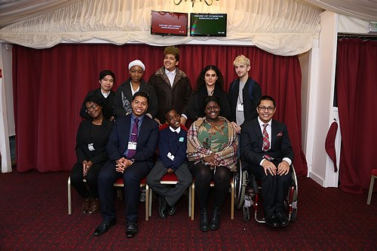

## 

## 

## Introduction

“By giving young people a real say and genuine decision-making power within the borough, we believe we can make Lewisham a better place to live in, not just for young people, but for everyone” (Sir Steve Bullock, Mayor of Lewisham 2006)

As a key priority for the Mayor and Council, the programme has provided a range of opportunities for children and young people to become engaged and it has ensured that young people have been consulted on the development and delivery of public services.

The Young Mayor Programme makes an important contribution to the objectives set out in Shaping our Future – Lewisham’s Sustainable Community Strategy 2008-2020. Of specific relevance are the priorities:

*‘Empowered and responsible – where people are actively involved in their local area and contribute to supportive communities.’*, and;

*“Ambitious and achieving – to Inspire our young people to achieve their full potential”.*

Corporate priorities: “*Community Leadership and empowerment: developing opportunities for the active participation and engagement of people in the community”*

The programme enables young people, politicians, council officers and partners to work together to develop ideas, while also addressing issues of concern and interest. In doing so, young people’s active and effective participation in democratic processes and local governance is genuinely enhanced. The Young Mayor’s Team continues to plays an active role in helping to develop community solidarity and cohesion particularly necessary in an era of austerity and retrenchment. As this period slowly comes to an end it becomes even more important to remind ourselves and young people that other ways of doing things and being in the world are both possible and viable through our active engagement with each other and the world around us.

The activity and work of the Young Mayor and Young Advisors are ways of pursuing these ideas and aspirations. Hopefully enabling young people to become who they want to be in a world which they’ve actively shaped, learning the necessity of principled compromise, working respectfully with difference and differences. This learning by definition is both practical and educational, experiencing critical dialogue the way others view the world and the challenges of taking the risk and responsibility of being involved as a creator.

The following page *Young Mayor and Young Advisors Work Areas* is an exert from the budget paper showing the work of the Young Mayor and Young Advisors for the year 2016/17 which was presented to Mayor and Cabinet in February 2018. The Young Mayor presents their budget at the end of their term as a report of work done and future priorities having consulted others throughout their year in office.

## Young Mayor and Young Advisors Work Areas: October 2016 - October 2017

|  |  |
| --- | --- |
| **Organisation / Project / Work area etc.** | **Activity** |
| Young Advisor’s Meetings | Regular meeting time for young people to plan and organise their activities and for partners/ colleagues/ peers to consult and discuss issues with the group. Thirty nine Young Advisor meetings were held during 2016/17. |
| Social Justice and Diversity | Participating in debates and panels on social justice and diversity.  Young Advisors created and presented an Equalities timeline presentation at full Council recognising the 40th Anniversary of the Race Relations Act.  Supporting and participating in events at the Stephen Lawrence Centre; policing and the voluntary sector. Young people’s voices and opinions being heard and shared with other community members and professionals such as the police and others, to help create change and influence policy making.  Representing young people at LGBTQ events including launch of LGBTQ Month and full council. Discussion about the prejudices they can face and how it’s possible to better support young people.  SEND Young People’s Forum with Special Needs Schools. Young People from SEN schools meet together with Young Advisors and adults to look at what their needs/interests are and involve organisations who provide activities or can plan activities to meet the needs/interests of the group.  Discussion about the Poverty Commission with Cllr Dromey and participating in the community wide event, contributing young people’s experiences of poverty.  Working with SACRE – RE curriculum, reading, discussing and providing ideas on the review of the RE curriculum for all key stages, so it better meets the needs/interests of young people in Lewisham.  Participating in the Serious Youth Violence Conference, preparing and gaining views at People’s Day and presenting to a conference of community members.  “13 Dead Nothing Said” Workshop for schools, helping facilitate a day at Goldsmiths with Lewisham Schools exploring the exhibition, the New Cross Fire and their local history. |
| Civic Events | Young People from the Young Mayor Team attend events to show solidarity and recognise the importance for the wider community of events with important historical roots.  Recognising achievements and being involved in and learning about other civic institutions.  As elected representatives this is part of the role and is important both for them to attend and for others to see they recognise and take these responsibilities seriously.  Primary school council and Mayor Meetings.  Holocaust Memorial Day event.  House of Lords Visit with Chair of Council and dignitaries.  Supporting citizenship ceremonies.  Council AGM / Full council Meetings  Visit to the Foreign and Commonwealth Office. |
| Intergenerational Activities | Working together with older people to build understanding through intergenerational projects.  Attending Positive Aging Council meetings.  Quiz with Positive Aging Council.  Supporting the POSAC *Tammy whynot* event. |
| Health | Responding to consultation on the Public Health proposals for a new Young Peoples’ Service, and being part of the commissioning group for the new service  Regular update with the CCG about local developments.  Meeting with Brook about the sexual Health Services they provide for Young People.  Liam continues to work on the National NHS Youth Forum, working with young people across UK on campaigns  School Nurse Consultation; contributing views on the effectiveness of school nurses.  Dementia Friendly workshop to understand the experience of others and be able to recommend others get involved. |
| Employment and Enterprise | Supporting opportunities for young people, activities, jobs and training through sharing on Facebook and through informal networks.  Work experience students from 7 schools plus 10 students on work experience doing a two week Voter Registration campaign. |
| Working with Children and Young People Directorate including Lewisham Youth Service/Youth First | Organising showcases and other events at the TNG, for Lewisham Live, an open Mic night.  Update and discussion on progress of Youth First.  Budget consultations at some youth clubs and centres. Talking to young people about the Young Mayor’s budget and what it should be spent on.  Post 16 conference at Goldsmiths College.  Contributing to the CYP Autism review.  Meeting with CYP Select Committee and Cllr Moore to identify in depth review: contributing to the in depth review on Transitions from Primary to Secondary school. |
| B-involved Website and Facebook | Promoting opportunities for young people, raising issues of interest and maintaining social media contact with peers. Work experience students in particular support the site and social media. |
| Community Safety, Policing and Youth Justice | Roundtable events with the Tutu Foundation and the police; role play and frank discussion about the experiences of young people and the police to increase understanding.  Workshop around stop and search with Y Stop –understanding your rights and being able to talk to others about rights and responsibilities.  BBC programme on serious Youth Violence with Vicky Foxcroft MP.  Participating in the Youth Violence Commission with Vicky Foxcroft MP.  Developing knowledge of and supporting young people involved in the Youth Justice System, through the YOS engagement group.  Hate Crime Awareness week supporting the White Ribbon Campaign, awareness building in the community and for young people. |
| Regeneration and Housing | Contributing to the consultation with Team Catford including a discussion on affordable housing.  Speaking at Housing Away day about work of the Young Mayor and priorities. |
| Working with Schools and Colleges | Visits to primary, secondary schools and colleges: campaigning, raising awareness, budget consultations and feedback through assemblies, citizenship days and school councils. Supporting peers at exhibitions, achievement events and activities.  School visits to the civic suite including, school council meetings and primary school visits with the Mayor.  Termly School Council Meetings at the Civic Suite: hosted by the Young Mayor and Young Advisors with school council representatives.  Masters Student on placement from Goldsmiths College, working with Young Advisors.  Young Mayor Budget consultations, talking to students about priorities for the budget, getting their views and ideas. |
| Community Events and Organisations | Attending community events representing young people, recognising achievement, encouraging participation, cohesion and volunteering, for example:  Smashfest; Young Lewisham Project AGM, Blackheath Fireworks; Preschool Alliance Community Event; Sedgehill Summer Sizzler; Supporting Love to Dance.  Participating in Lewisham Youth Conference as inspirational speakers.  Supporting the development of the “What’s the Story” project for young people with Lewisham Library and Goldsmiths College.  National Citizenship Service professional visits and Dragons Den events.  Participating with European guests at St Mungo’s on the Young People’s gardening project.  Young Mayor Funding pot process engaging with local groups and supporting projects young people have identified.    Consultation and participation in Lewisham Local including initial young people’s volunteering day at Ladywell Adventure playground. To be an ongoing programme of days encouraging young people to volunteer in different ways.  Consultation and participating in developing the Borough of Culture bid. |
| Sports and Arts | Open Mic night as part of Lewisham Live with Phoenix housing Young Makers Group.  Supporting People’s Day and young people’s performance opportunities.  Peoples Day work experience programme with European visitors as part of an Erasmus+ project.  Working with Fusion to promote opportunities for young people in their leisure centres.  Supporting local football tournaments. |
| Visits to Westminster, meeting politicians and supporting voter registration events. | Young people developing knowledge and understanding of party politics and democratic engagement which can then be shared with their peers.  Visit to the House of Lords and meeting with Lords, developing an understanding of how decision making process work.    2 weeks of voter registration campaign with 10 work experience students. Students developing their understanding of democratic processes and reasons to vote. Students visiting different areas of Lewisham (leisure centres/ market/ libraries etc.) and encouraging people to vote. Visits to all Lewisham sixth forms and colleges to register young people to vote with presentations and publicity, tablets to register people there and then.  Meeting with Councillors around housing, refugees, select committees, food bank, serious youth violence, mental health and wellbeing, youth services, poverty commission. |
| UK Youth Parliament (UKYP) and British Youth Council (BYC) and other Regional and National work. | Engagement with the national Youth Voice Strategies and meeting other young people who are representing their areas.  Representing Lewisham at House of Commons UKYP Annual Sitting.  Participating in the Peer Outreach Project – GLA Peer Outreach Team.  Attending BYC conventions and meeting other young people who are active in their communities across London and the South East.  Understanding the regional opportunities for young people and how to get involved in and influence policy making across London. |
| European visits / visitors | Erasmus+: Youth in Action Projects (European funded projects) with youth groups in Alingsas near Gothenburg, Sweden. Prague 7, Czech Republic, Santa Maria da Feira, Portugal.  With the aid of Erasmus+ grants we visited Alingsas outside Gothenburg to find out about how they work with young people who are NEET, and training and enterprise initiatives.  One young advisor was invited to share his interest and knowledge of robotics with our colleagues in Portugal at a European Trade Fair. Also attended, in a personal capacity by the Deputy Mayor, Cllr Smith. As well as in Schools and Events in Alingsas, Gothenberg.  Young people from the three countries came to work with Young Advisors on Peoples Day to gain some experience, Also a visit from our colleagues in Portugal who came to take part in workshops around migration, and to share cultural and other interests with young advisors.  Some of the group visited Portugal to continue this discussion and to take part in the Medieval Festival, with their Young Mayor Programme.  The aim being to share ideas around citizenship, develop an understanding of what it means to be European, raise aspirations and be part of a wider world.  We have partners in Mallorca, Reggio Emilia, Italy, Santa Maria da Feira in Portugal, Prague 7, Bordeaux in Paris who we are developing projects with through the European programme Erasmus + including a Hub to promote young people’s mobility, training and work experience.  Supported Lewisham Polish Centre and Warsaw University’s research into the participation of young people with polish heritage in Lewisham. |
| Research and Evaluation Projects | Young People taking part in interviews and helping evaluate the Young Mayor Project. Conducting an exit poll for the young mayor’s election, interviewing candidates and recording their journey and experiences.  Continue to follow candidates and record their experiences, creating a longitudinal study conducted by Dr Kalbir Shukra, Goldsmiths College. Kalbir wrote a paper for the Youth in Policy journal around some of her findings, and submitted evidence to the House of Lords Citizenship and Community Engagement commission.  Young Advisors participated in some research with Dr Robert Chaskin, from the University of Chicago writing about young people from marginalised groups engage with civic and political systems. |

## Young Mayor Budget Priorities 2016/17

**Curriculum for Life**

To work with others across the borough to develop a curriculum for life, identifying what young people want to learn which is currently outside the mainstream curriculum. This could include things like first aid, mental health and wellbeing, debating and discussion about ethical, social and world issues to help form opinions and build confidence and self-esteem. It could also include practical issues such as knowing about rights in employment, taxation and pensions, an extension of preparing young people for life after/outside school.

Young advisors will visit schools and youth clubs to research and draw up recommendations for the subjects and issues to be covered. They will present these ideas to strategic bodies such as the Head teachers briefing, governors and Secondary Challenge to see where these ideas can be fitted into policy development and school plans, taking into account the pressures that schools are already experiencing.

The budget will be used to pay for activities and sessions which will be piloted in some schools, suggestions include activities such as first aid workshops, debates, and mental health awareness.

The curriculum for life is also one of the campaigns of the UK Youth Parliament and our research will be fed into this national campaign.

**Total: £10,000.00**

**Curriculum for Enterprise**

To complement the Curriculum for Life is to identify and add to the opportunities young people have to learn about and experience being involved in enterprise culture as a response to changing work places. Working with existing opportunities in Lewisham and feeding into bodies such as the Business Support Providers Forum, Business Advice service, Education Business Partnership and youth organisations like Young Enterprise to strengthen the pathways for young people in to this field.

The budget will be used to potentially pilot projects such as an enterprise s summer school and small pot for schools to apply to for support and enterprise project, an identified youth space for enterprise support.

**Total: £15,000.00**

## Youth Participation and Engagement: why the Young Mayor Model?

The Young Mayor’s Programme began formally with the 2004 Young Mayor Election, which was the culmination of a decade long successful young people’s participation project base in what was the Youth Service. It was intended to mirror the political structure of the borough particularly given the change to a directly elected adult Mayor of Lewisham, so that there could be a formal and constitutional recognition of the voice of young people and its need for representation in the borough.

The initial idea of a Young Mayor had been piloted in Middleborough but had only lasted for one year. In developing the Young Mayors programme in Lewisham, a number of key challenge were being addressed – including increasing the participation of young people in the life of the borough through a formal structure that worked centrally and closely with elected politicians. The Lewisham programme, which was also initially on a pilot basis, will be electing the 15th Young Mayor in October 2018.

The programme sits distinctly in the Mayor’s Office in Lewisham instead of the Children and Young People’s Directorate, as this is key in providing genuine dialogue between the Executive Decision Maker (Directly Elected Mayor) in the council and the Young Mayor and his/her advisors. The programme is part of the constitution and base budget of the Council.

*The Young Mayor and Election process*

The key components of the project are the elected Young Mayor and the work of the Young Advisors Group. Each October a Young Mayor is elected by young people from across the borough. The elections are promoted and held in every secondary school and college in Lewisham. The school registers are used as they closely resemble an electoral roll for young people.

Provision is also made for postal voting for young people educated outside the borough or not in school for any other reason, and ballot papers are sent to all home-educated young people.

Candidates must either live or attend school/college in Lewisham borough and be aged 13-17 years. To stand for election each candidate must obtain nominations from 50 of their peers and attend a one day training session. The training includes how to write a manifesto and run a campaign and what to expect if you get elected. Candidates are encouraged to set up a “Campaign team” of their peers to support them and they have just over 4 weeks to campaign. The candidates are supported to take part in assemblies and street “hustings”, campaigning with leaflets on the street and using social networking to spread their message to their peers. Previous young Mayors and candidates contribute to the campaign training, sharing their experience and knowledge.

On polling day, the Council’s electoral services team run the election in exactly the same way they do for the adult elections. Ballot boxes, voting booths and electoral staff are stationed at each secondary school and college in the borough for the duration of the school day (+half an hour either side). All young people resident or attending a school in the borough aged 11 – 18 can vote.

The count is held the following day, again with the support of electoral staff, and young people assist in this process. The culmination of the process is the results ceremony where the new Young Mayor, Deputy Young Mayor (second place) and UK Youth Parliament Representative (third place) are announced. All candidates and their campaign teams are invited to join the Young Advisors Group.

Elections take place in October each year and Voter registration, for 16-18 year olds, is promoted at the same time. The Young Mayor team also run a voter registration campaigns twice a year visiting sixth forms and colleges in the borough.

*Candidates about to do a school assembly*

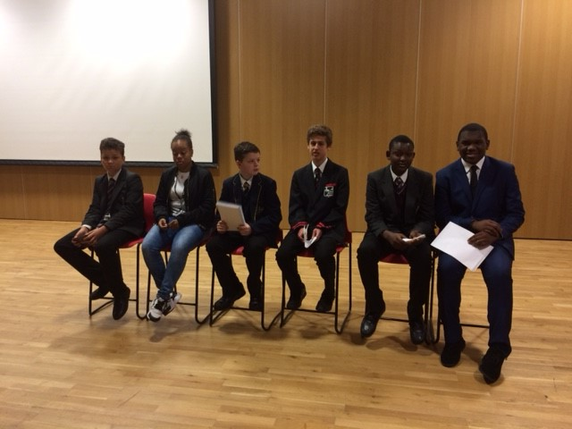

*Young Advisor’s Group – meet every Monday 5-7pm in the Civic Suite*

The Young Advisors are a group of around 25 young people who act in a similar capacity to a cabinet. There are three main ways that young people become a member of the group, they were a candidate or members of a campaign team in the election, they are member of a school council, youth group or other organisation in the borough, or thirdly any young person who has shown interest in getting involved, keeping the group open and accessible to as many people as possible. Currently the group comprises of young people from 10 years to 19 years with Young Advisors returning from university or work to take part. Though the Young Mayor term is one year many stay on as Young Advisors for a good few years, as do many of the Young Advisors. In doing so they are able to support others coming in and build their interests, experience and knowledge.

The Young Advisors share the work load of the Young Mayor and deputy Young Mayor, and importantly help in formulating ideas for spending the £25,000 budget.

Having identified ideas and consulted with other young people across the borough, the Young Mayors budget is presented to Mayor and Cabinet for approval.

As the project has developed there has been an increase in the demands made upon the Young Mayor. In this regard the Young Advisors have been crucial to the project. This ‘collective working’ between the Young Mayor and Advisors has enabled the initiative to get involved in a wide range of activities – it has also helped involve more young people in the process. This group meets weekly to support the business of the Young Mayor and to deputise at events where appropriate.

Regionally and nationally Lewisham Young Mayor’s Team also works with the Greater London Authority Peer Outreach Team, the British Youth Council, UK Youth Parliament, Partnership for Young London and other authorities.

Over 10 years the Young Mayor Team has built a substantial body of work with European partners through the Erasmus+ funding and the British Council. This has enabled projects and exchanges for the young people with organisations, authorities and young people in the following countries; Czech Republic, Portugal, Norway, Sweden, Italy, France, Croatia, Bulgaria and the young people have contributed to conferences in Sweden, Denmark, and Poland. The work has included developing relationships with politicians and officers in those countries in order to share good practice and develop policy.

*School Council Meeting in the Chamber*

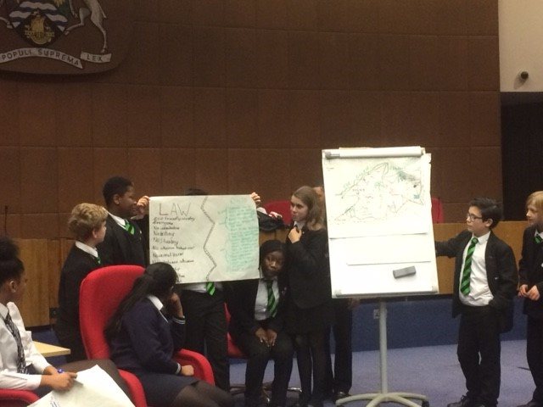

## Evaluation

Dr Kalbir Shukra from Goldsmiths’ University of London has been a carrying out an independent evaluation over the last six years comprising of participant observation/ ethnography of candidates, campaign teams and advisors. Based around what they think they are involved in and why they are involved. This has involved interviewing them, observing them formally and informally as well as talking to officers and politicians around the same themes. This is complemented by snapshot exit polls as some of the participating schools. Although small it comprises the only data of its kind in which young people talk about how they voted, why they voted and what influenced them. This is continuing, attached are some samples of impact and findings.

Appendix 1: Comparison of youth and adult participation; Dr Kalbir Shukra 2018

Appendix 2: Youth Participation in Lewisham Young Mayor’s Programme; Dr Kalbir Shukra 2018

Appendix 3: Evidence submitted to House of Lords Citizenship and Community Engagement commission; Dr Kalbir Shukra, Malcolm Ball and Katy Brown

**Contact:**

Please get in touch with Katy and Mal if you would like to find out more and/or meet with the Young Mayor and Young Advisors.

The Young Mayor and Young Advisor meet Every Monday 5-7pm in the Civic suite, please just let us know if you would like to come and meet them.

[Katy.brown@lewisham.gov.uk](mailto:Katy.brown@lewisham.gov.uk) 0208 314 6313 mob: 07957198312

[Malcolm.ball@lewisham.gov.uk](mailto:Malcolm.ball@lewisham.gov.uk) 0208 314 63564 mob: 07957198308

We are currently based on the second floor of the Civic Suite, Catford

## Appendix 1: Comparison of youth and adult participation; Dr Kalbir Shukra 2018

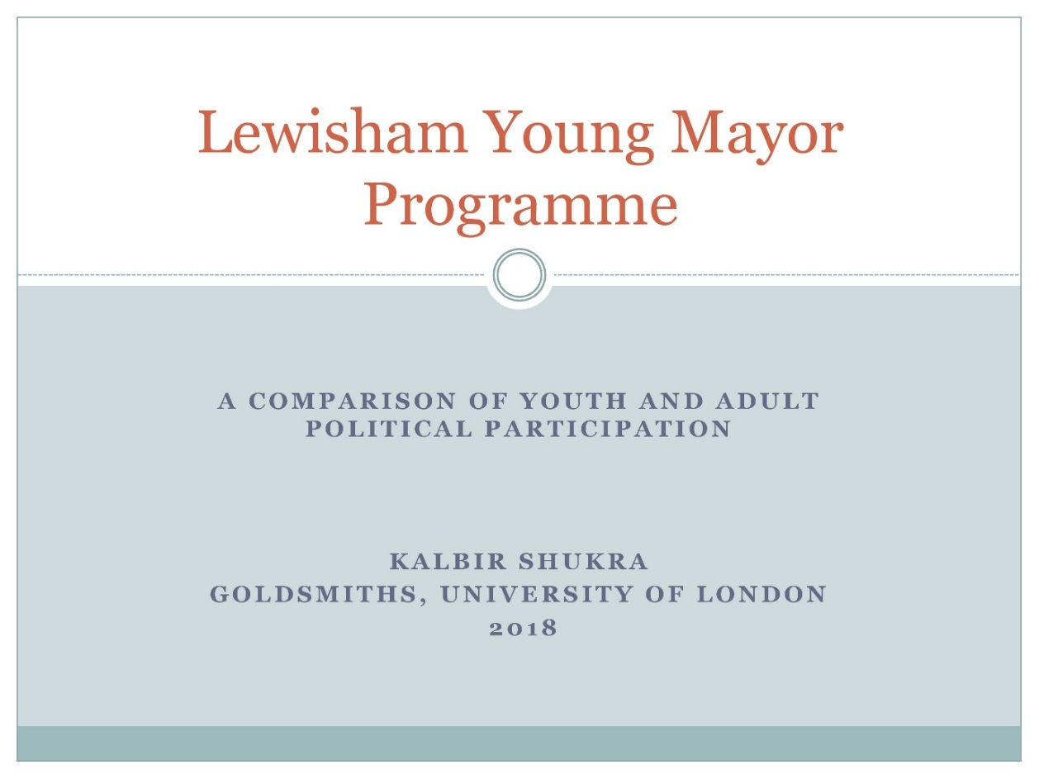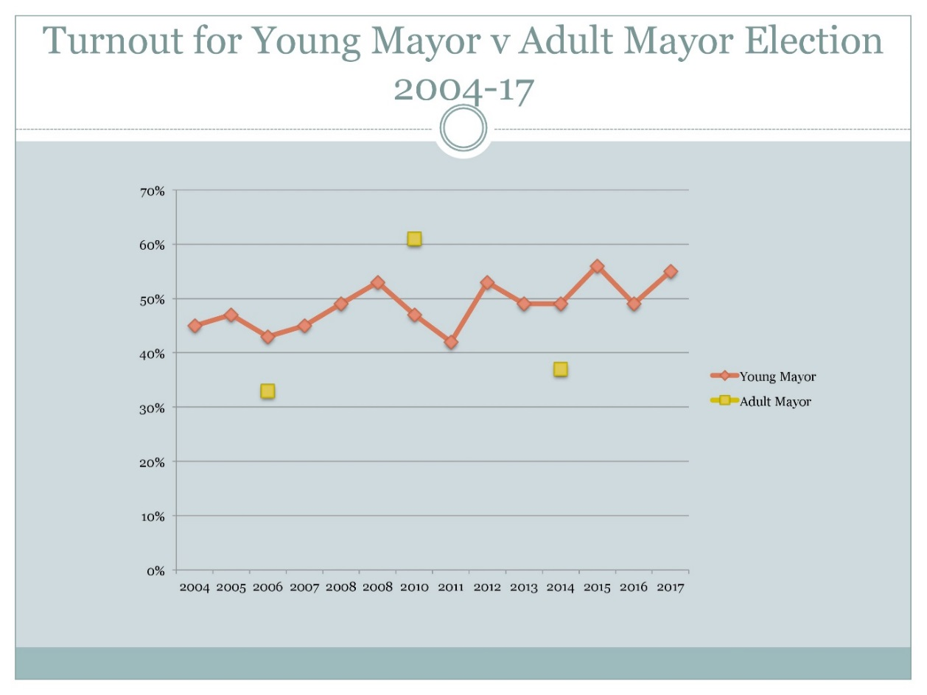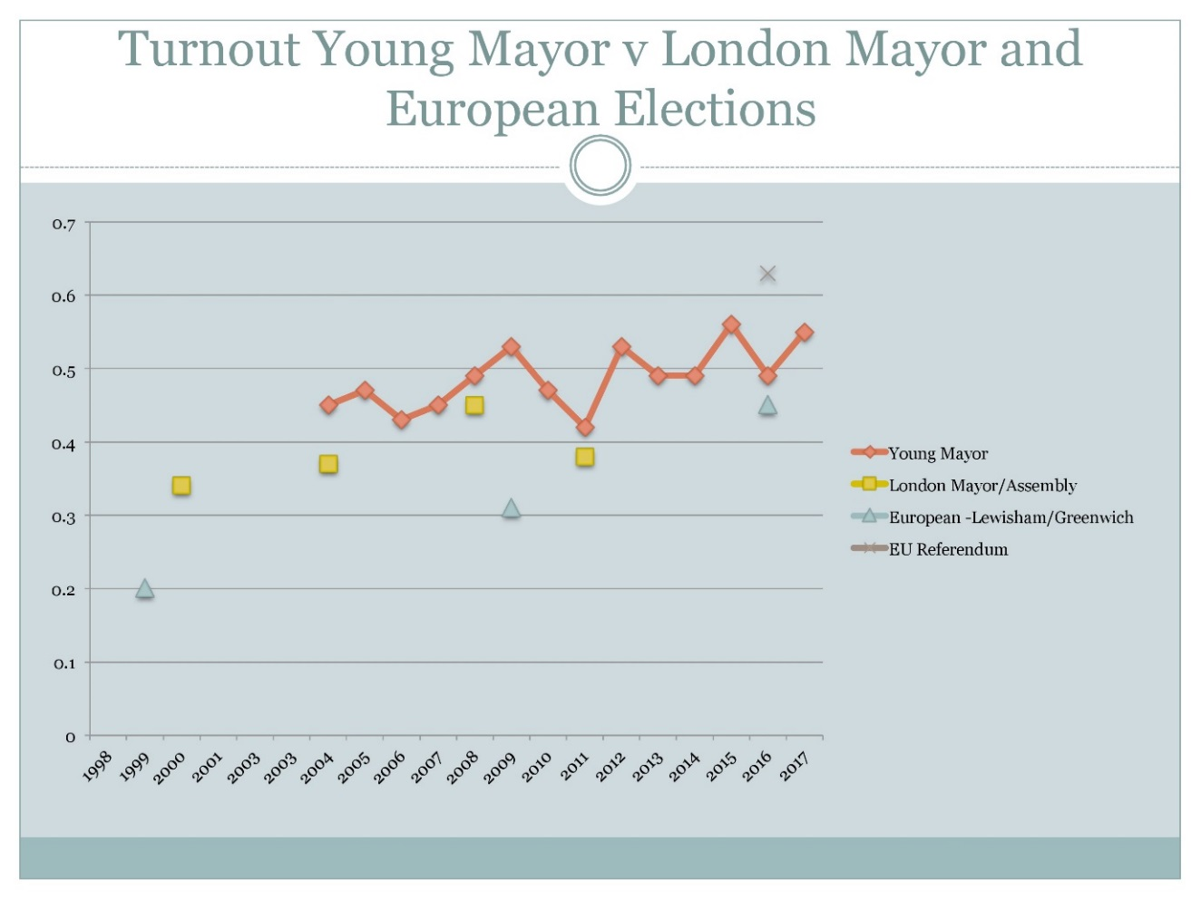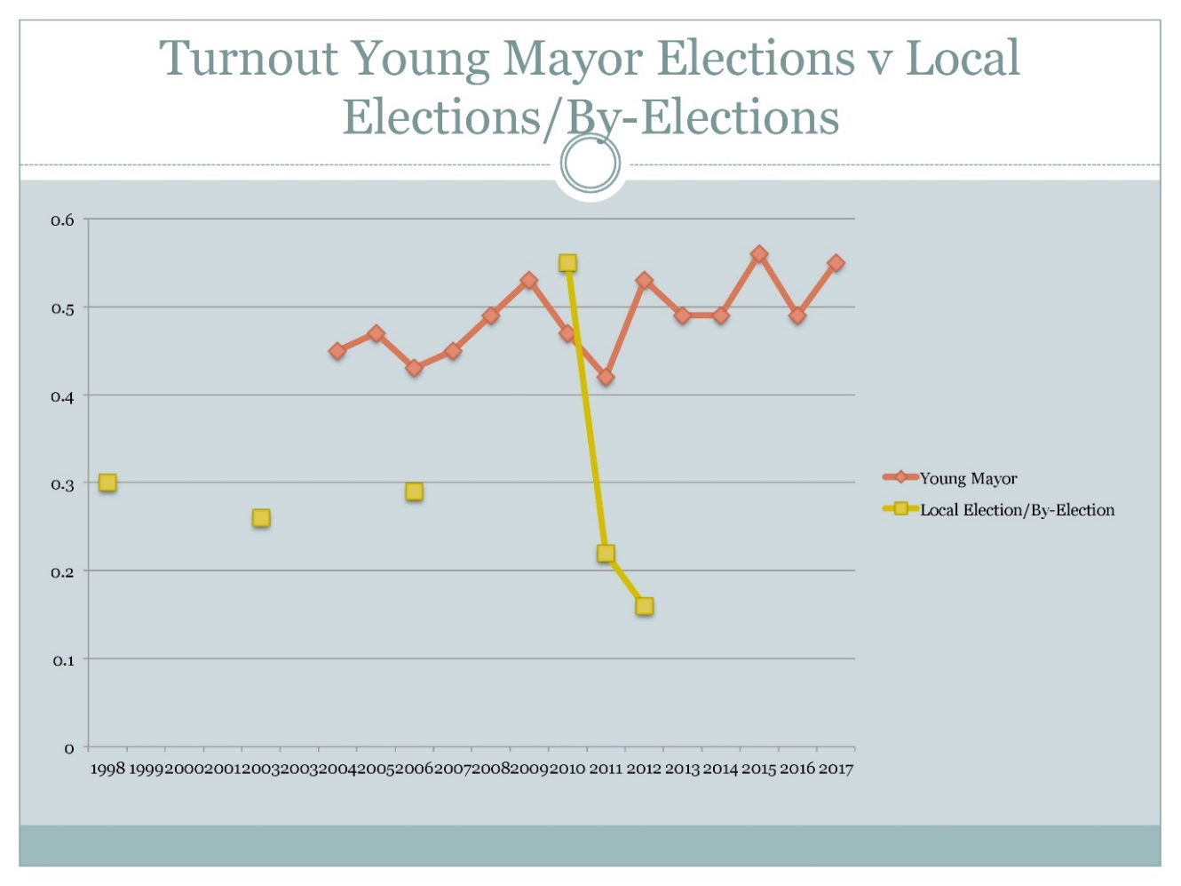

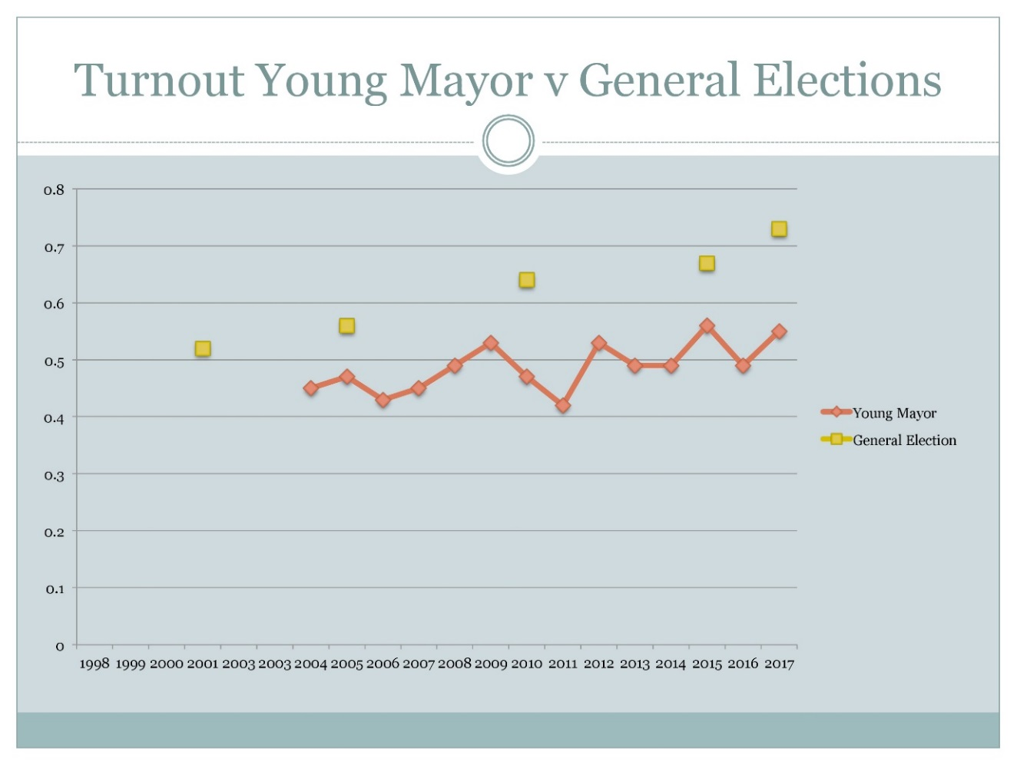

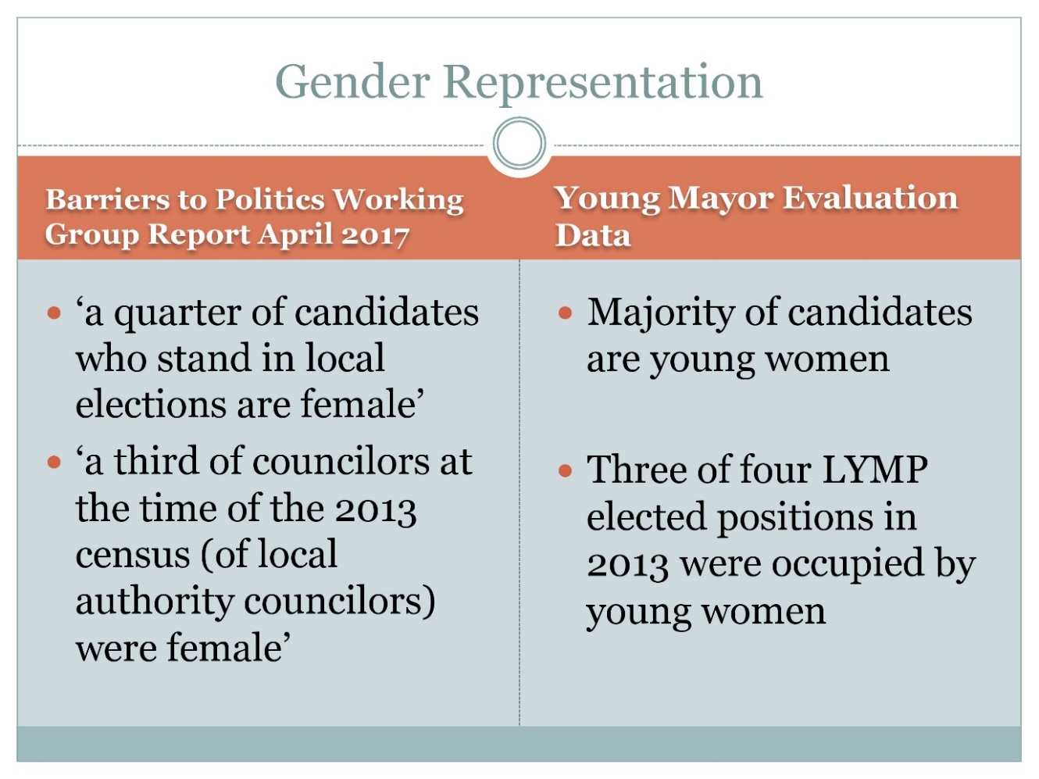

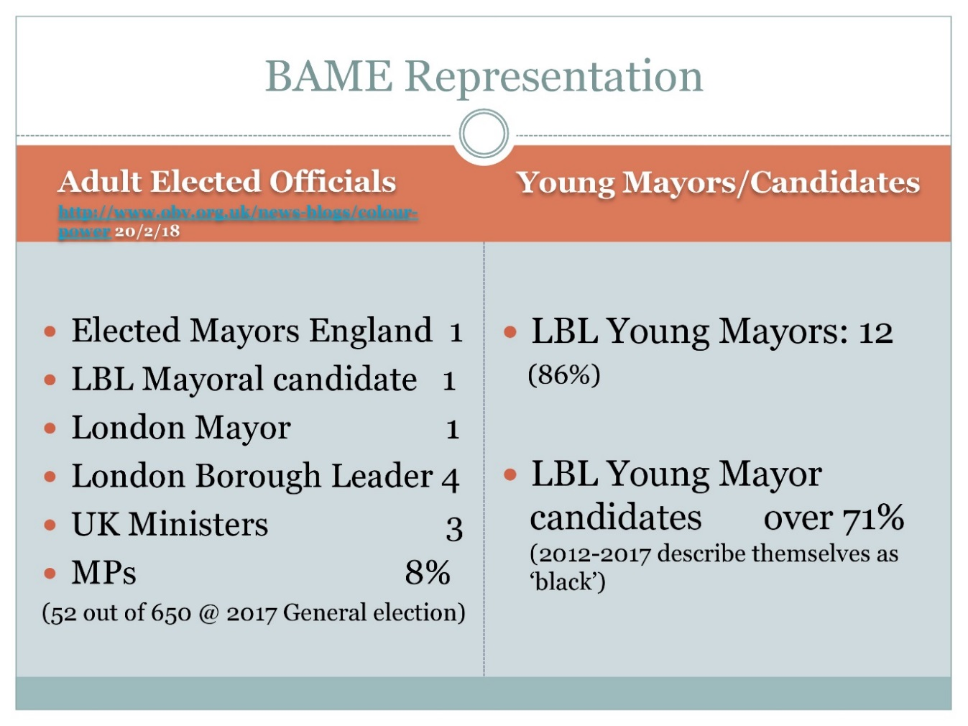

## Appendix 2: Youth Participation in Lewisham Young Mayor’s Programme; Dr Kalbir Shukra 2018

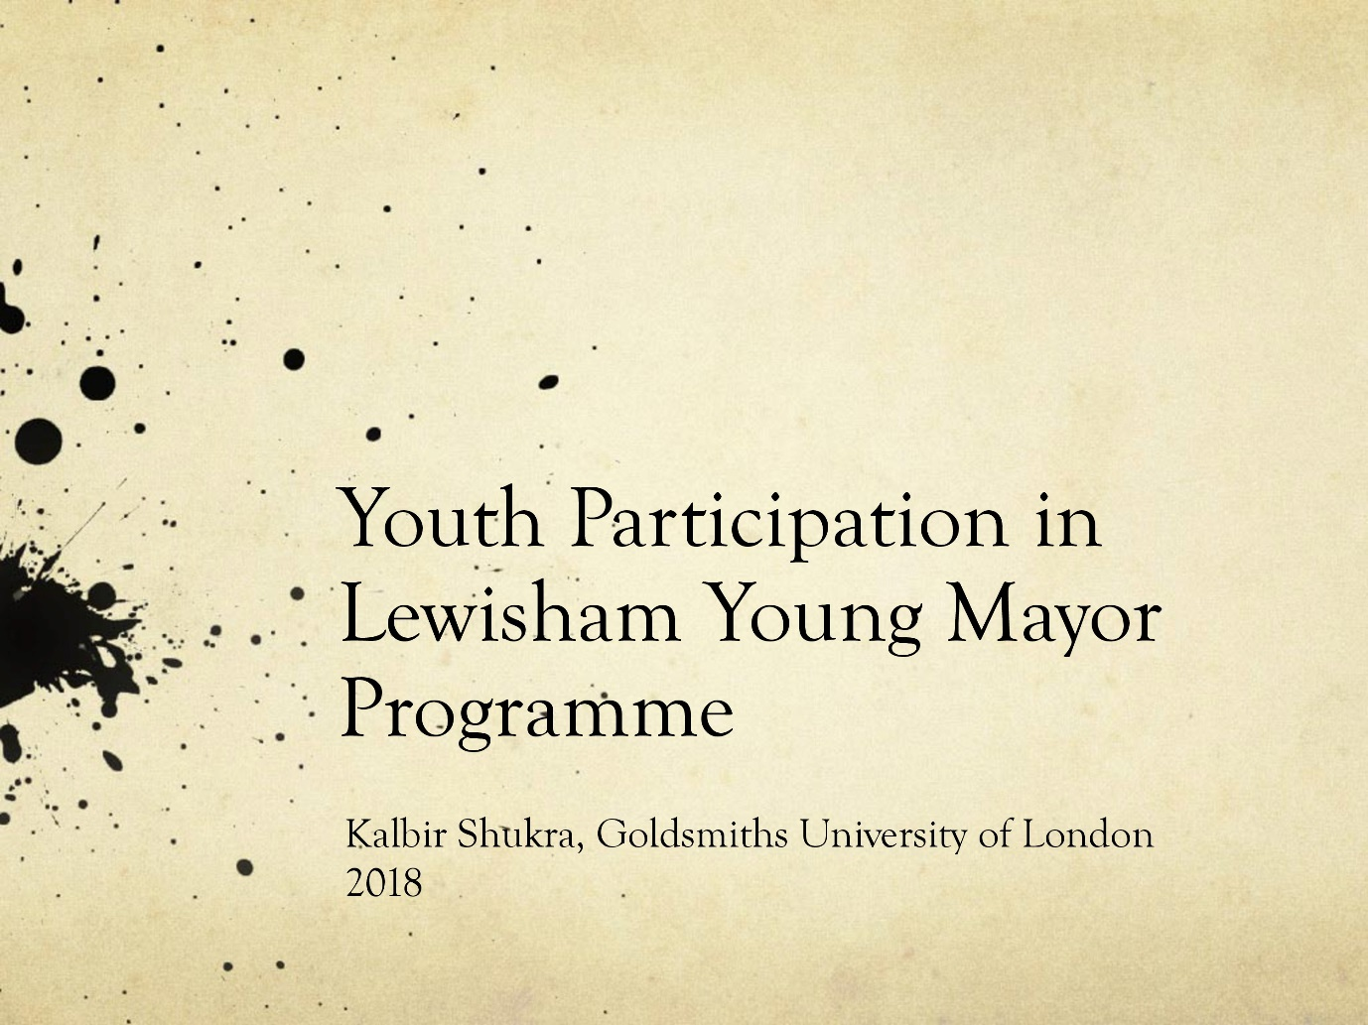

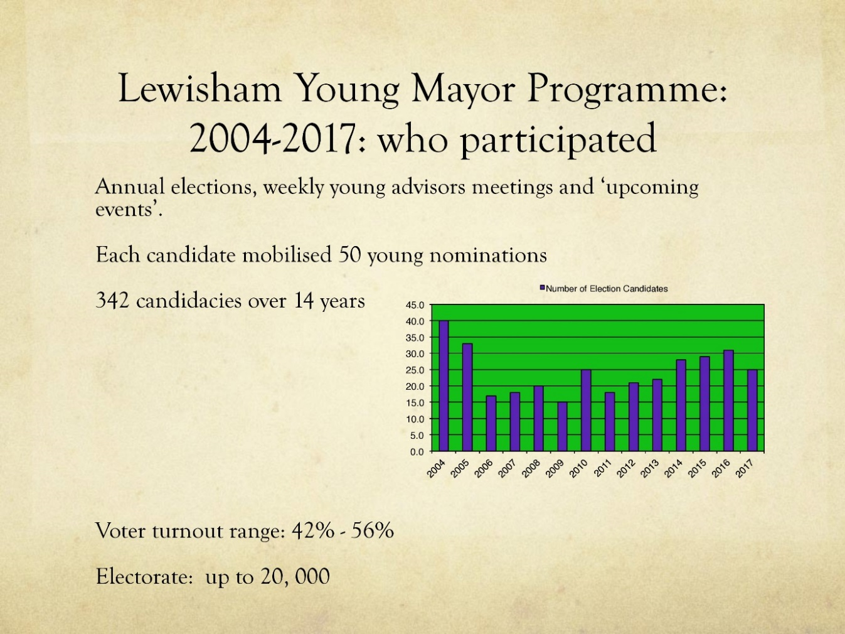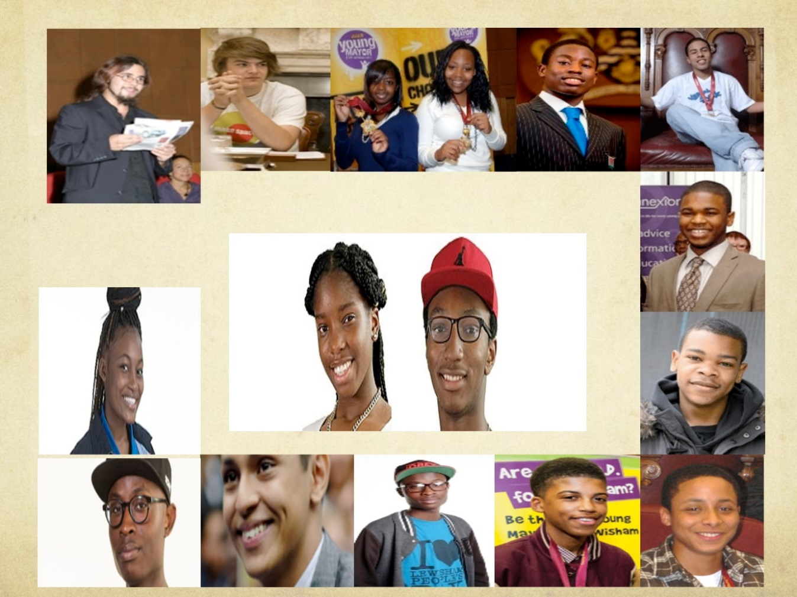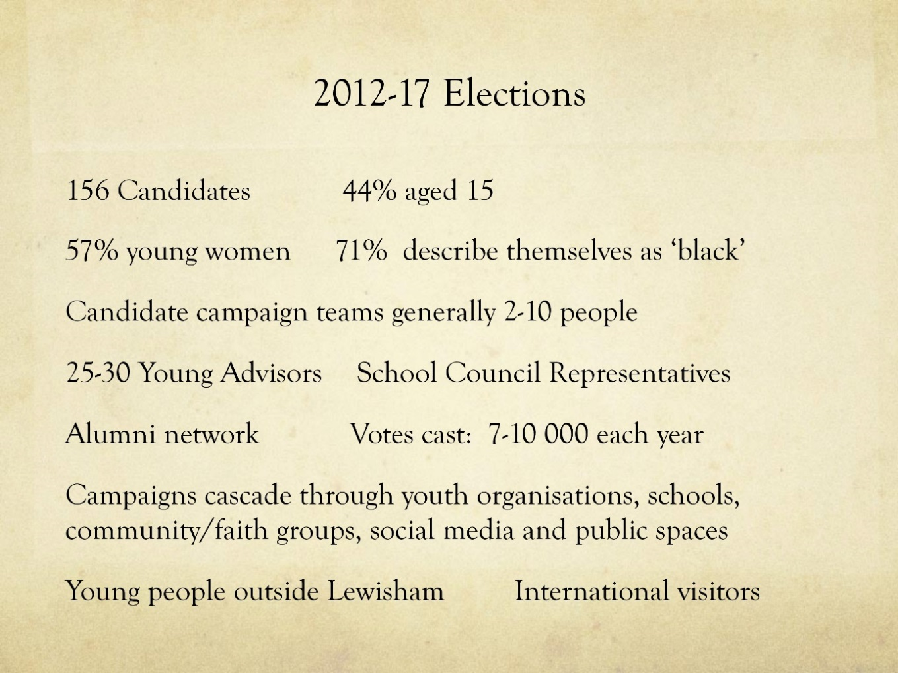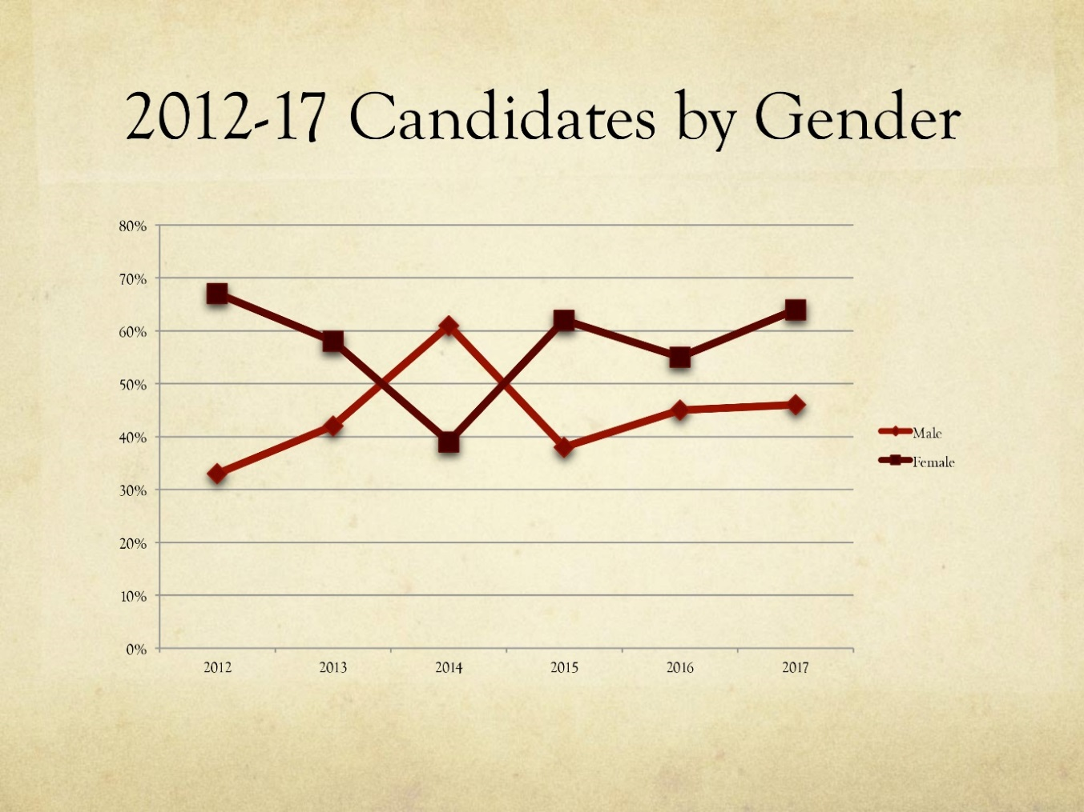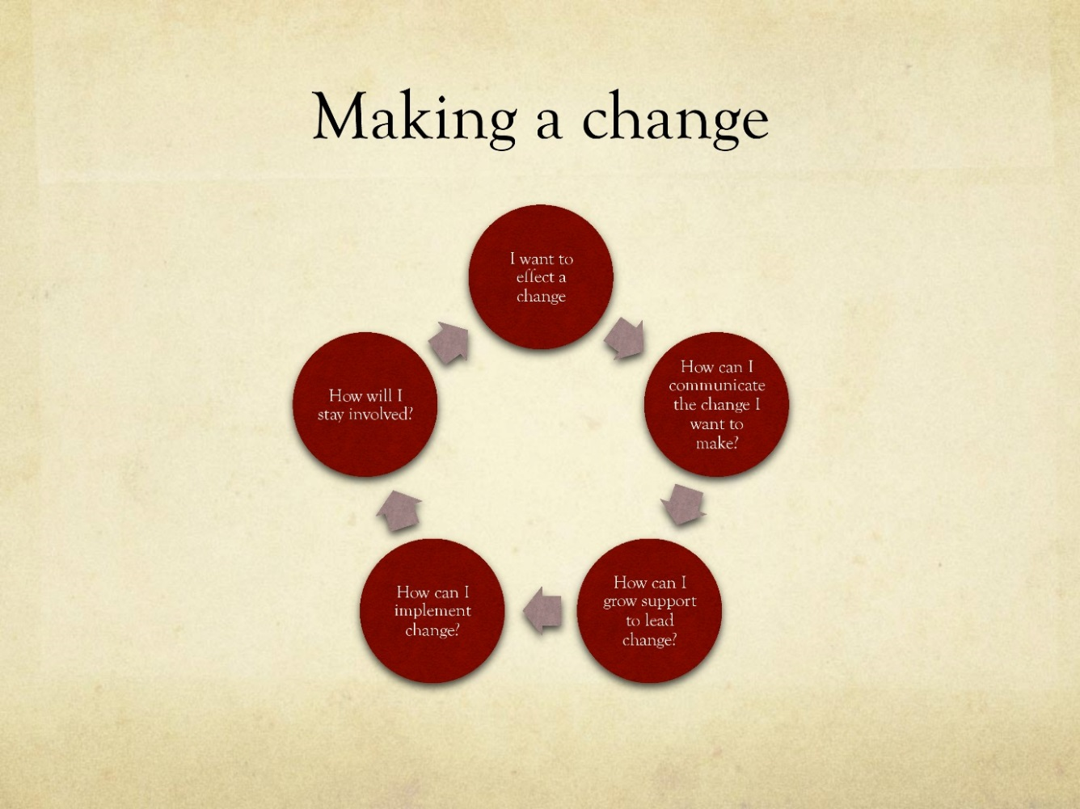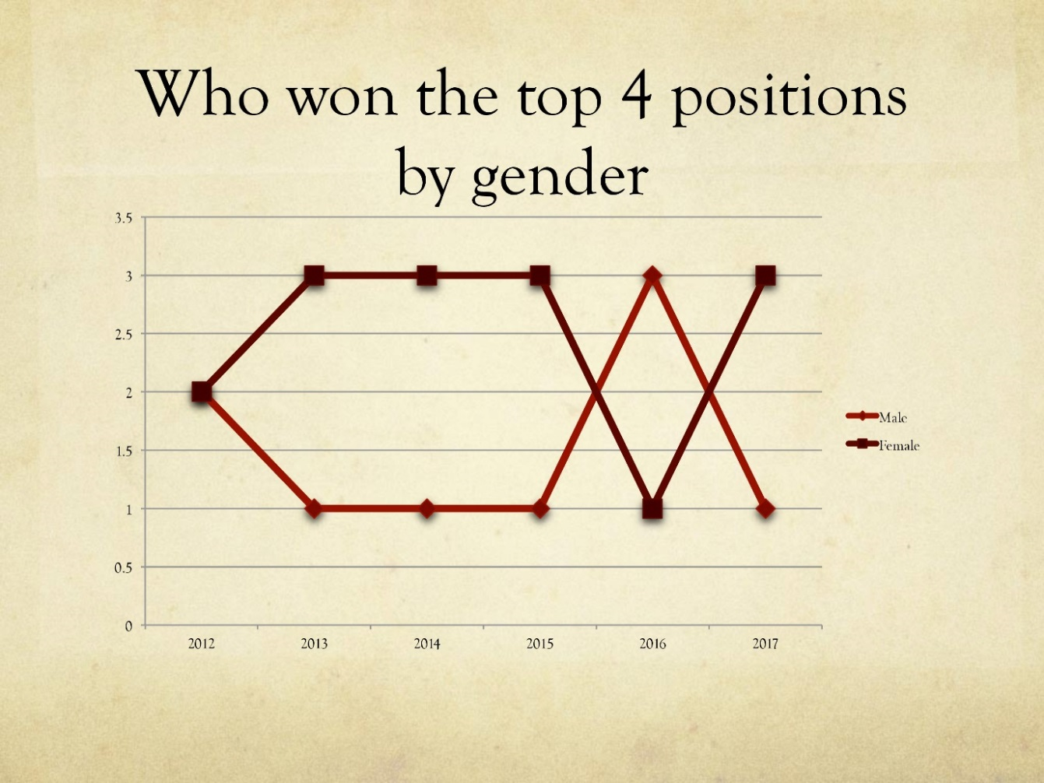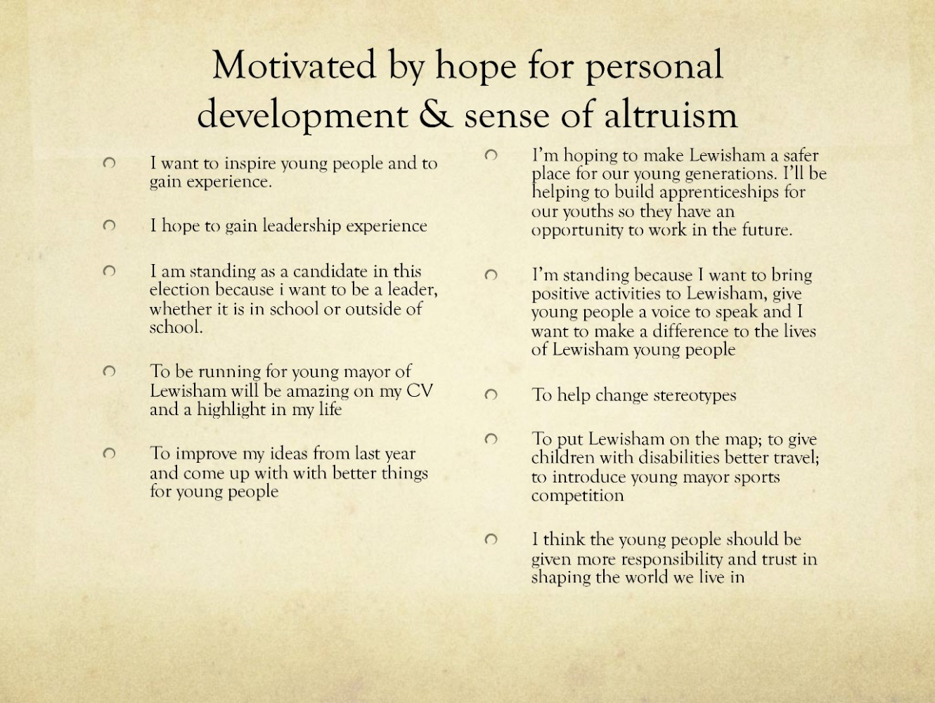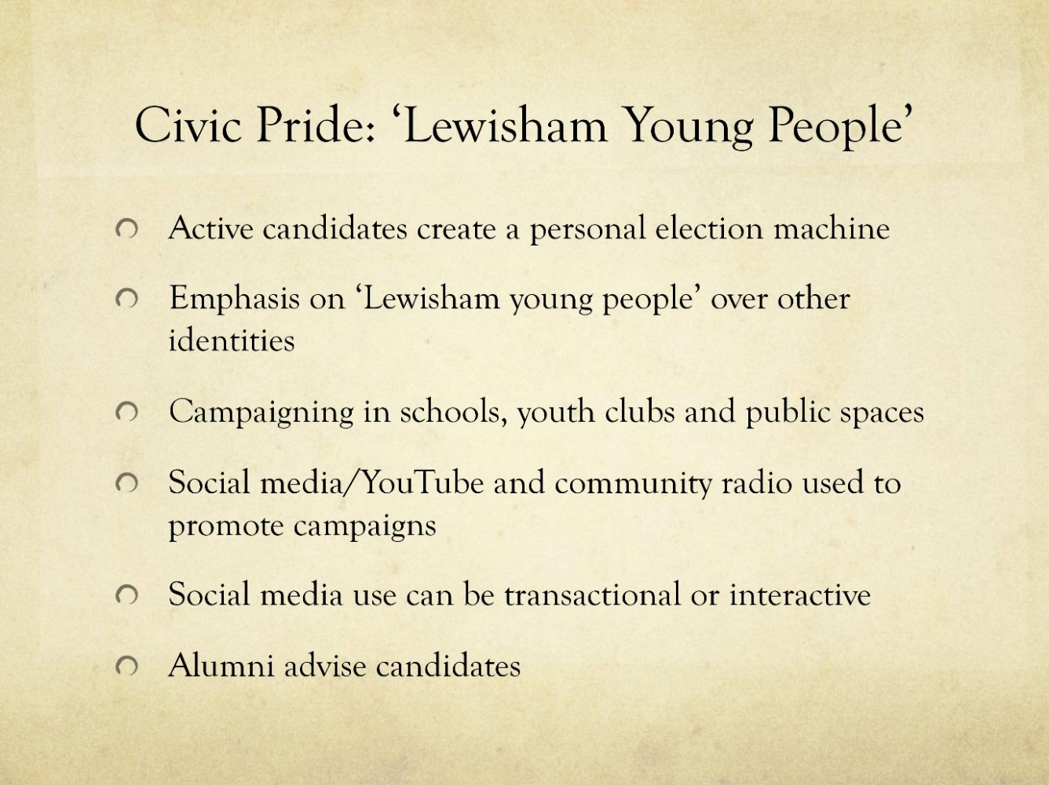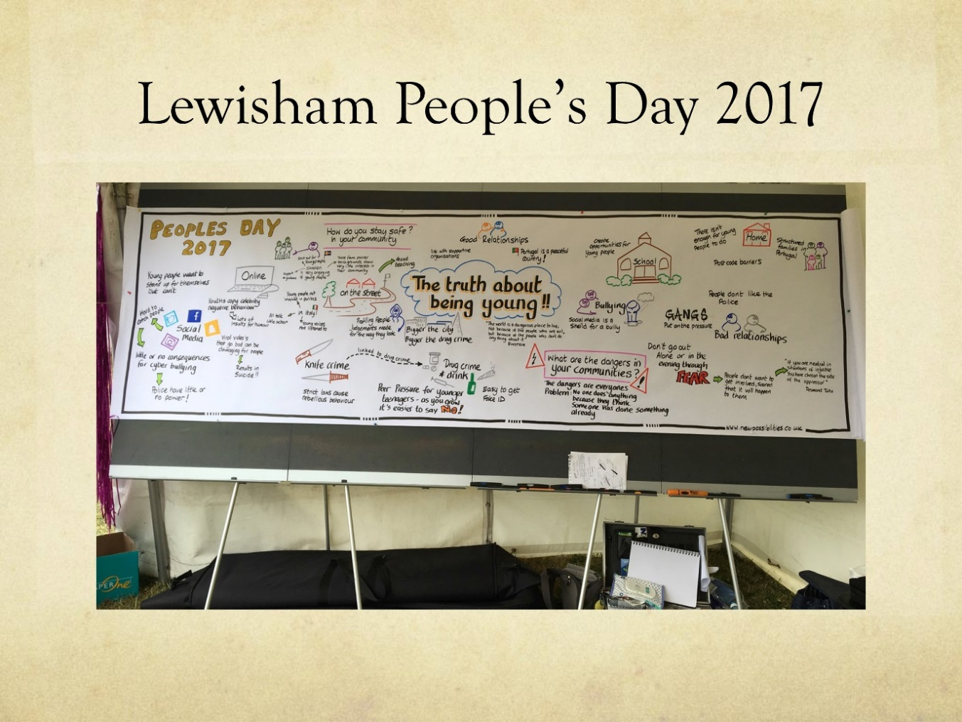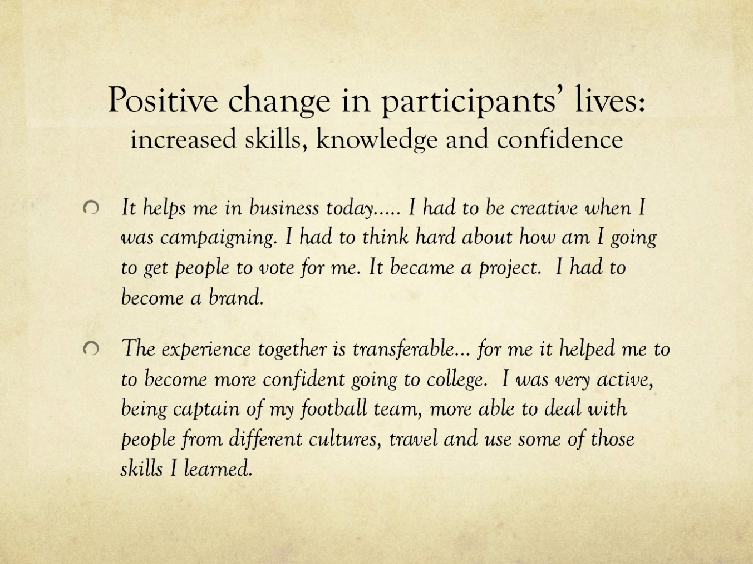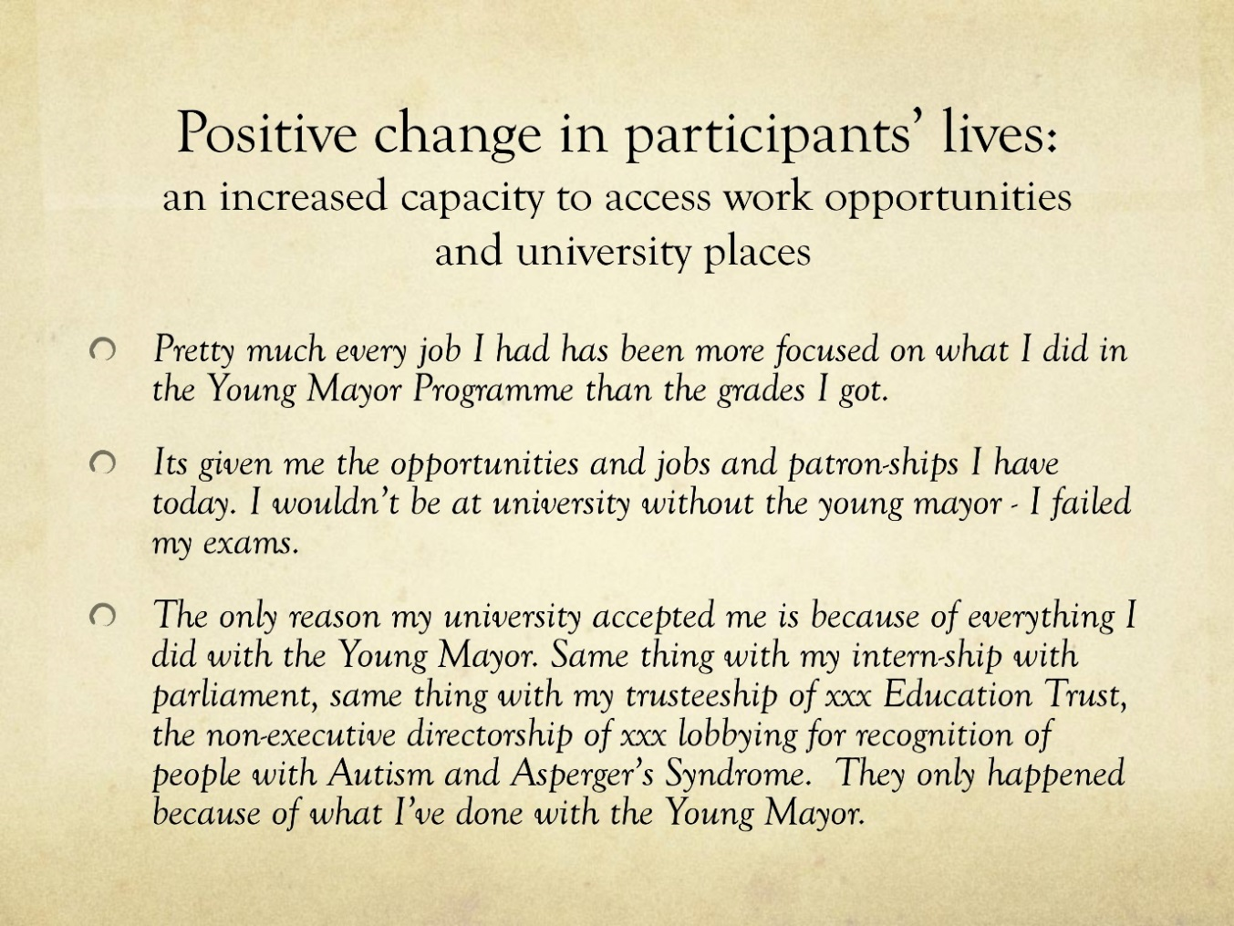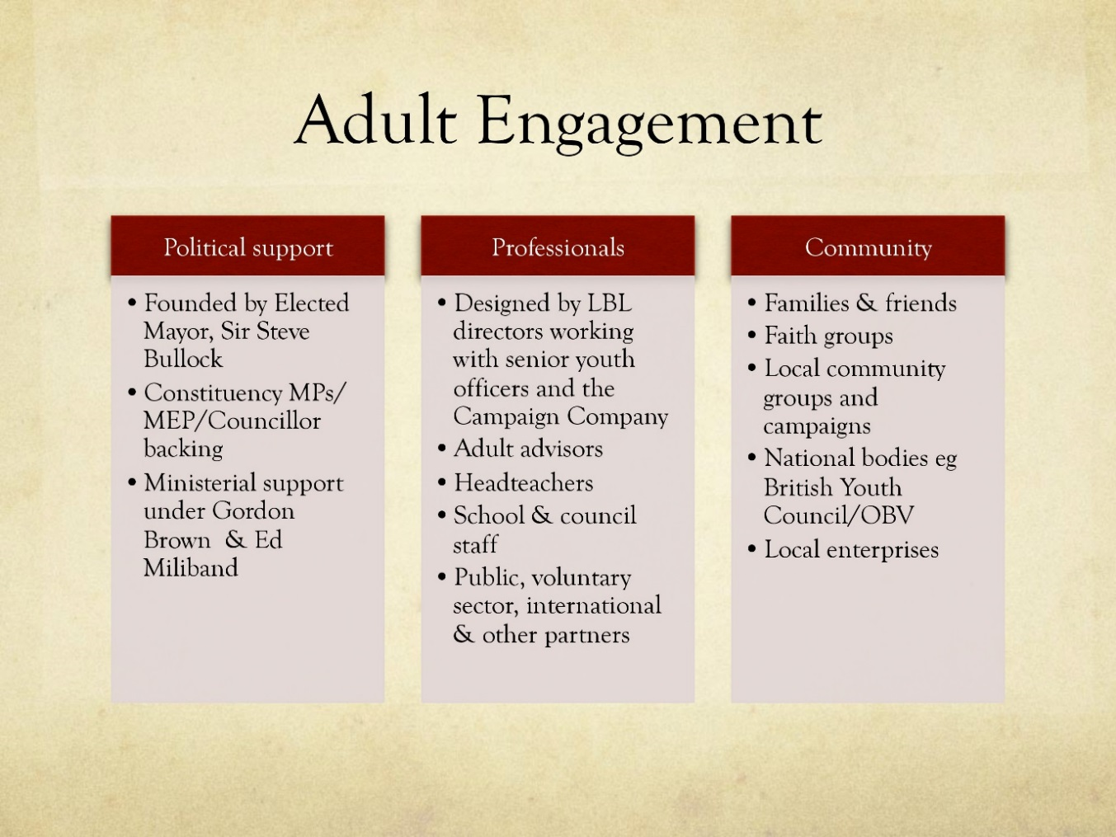

## Appendix 3: Evidence submitted to House of Lords Citizenship and Community Engagement commission; Dr Kalbir Shukra, Malcolm Ball and Katy Brown

## Appendix 4: Candidate PackC:\Users\kbrown\AppData\Local\Microsoft\Windows\Temporary Internet Files\Content.Word\page-0.jpg

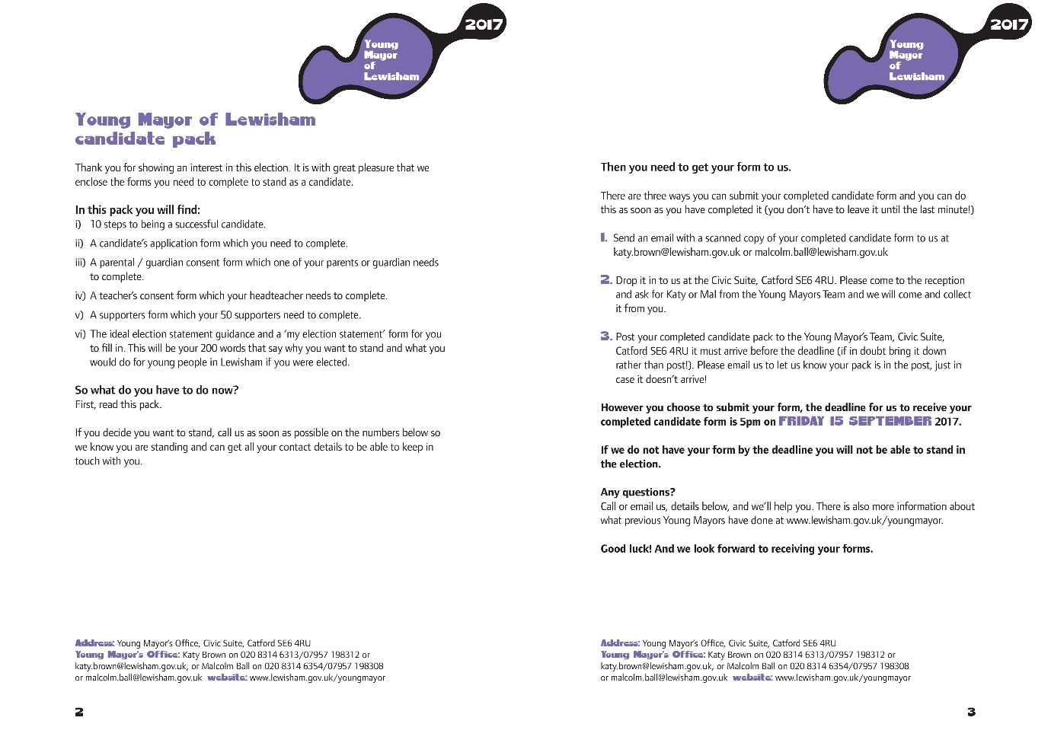

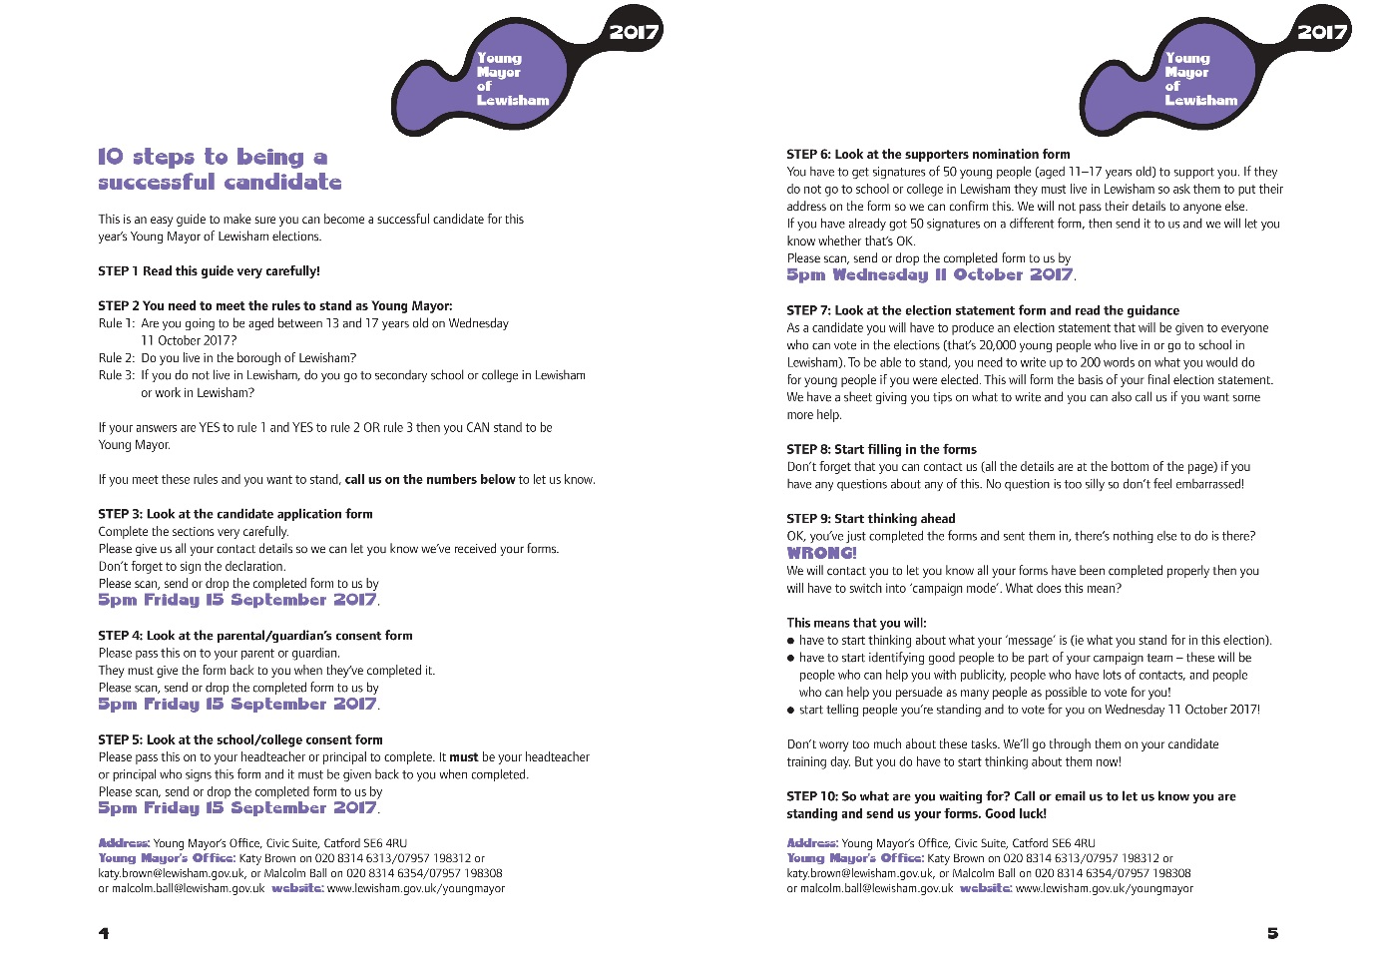

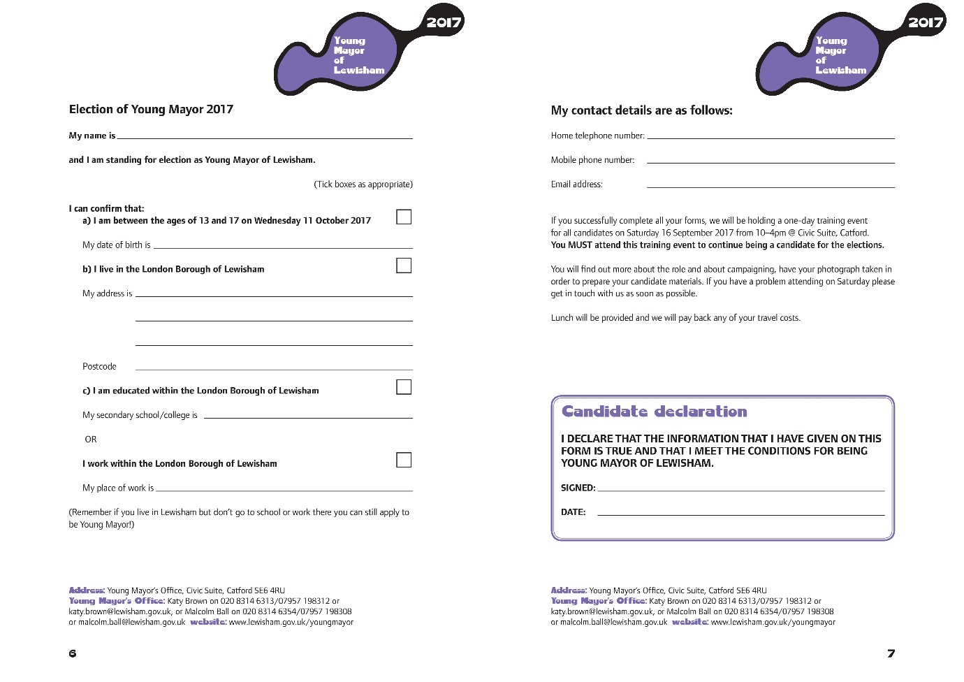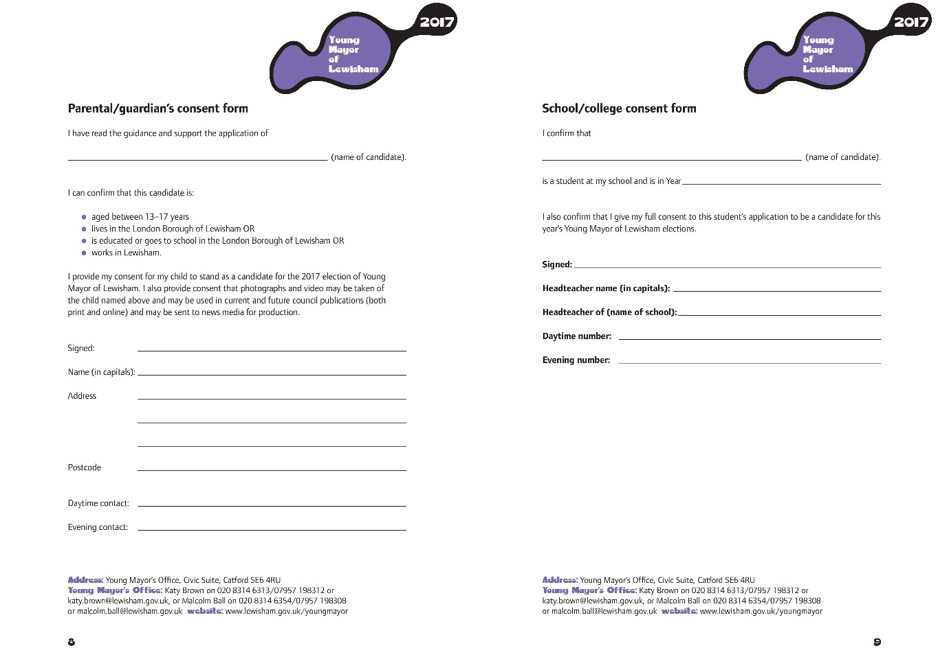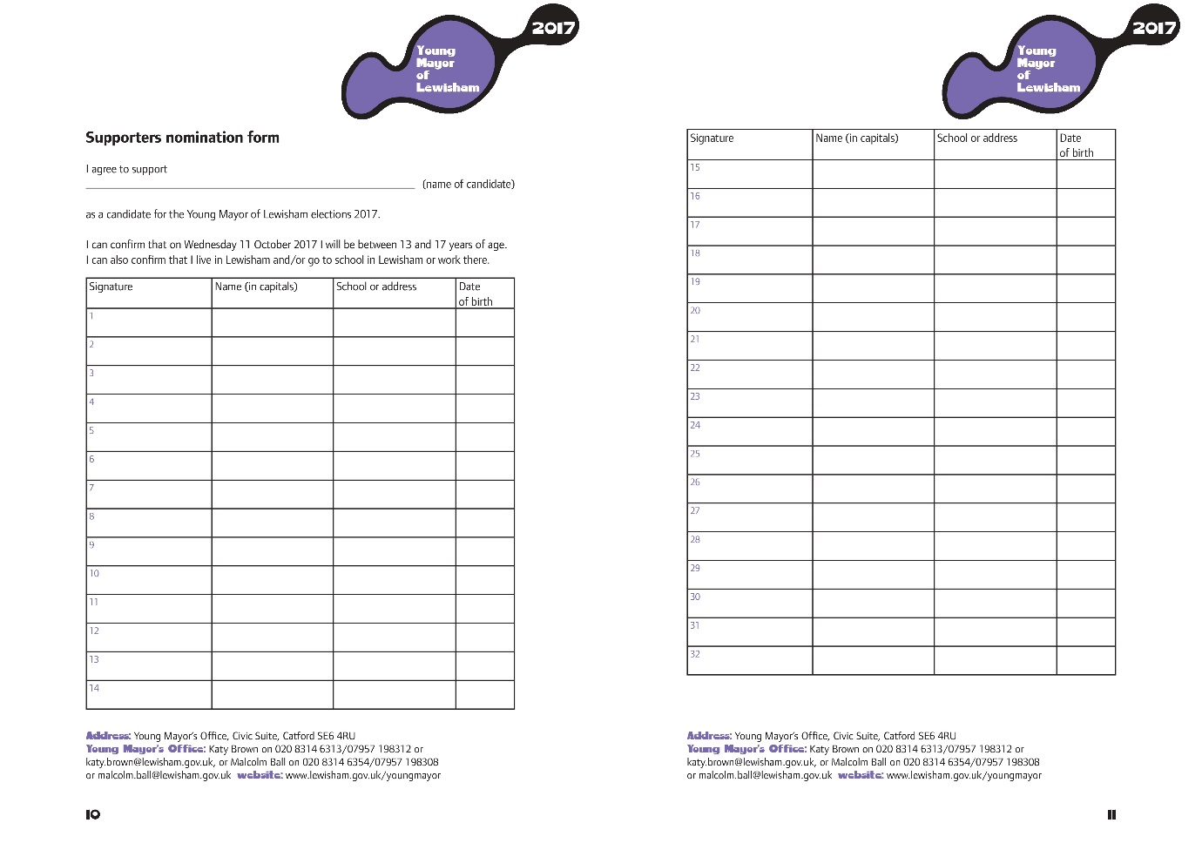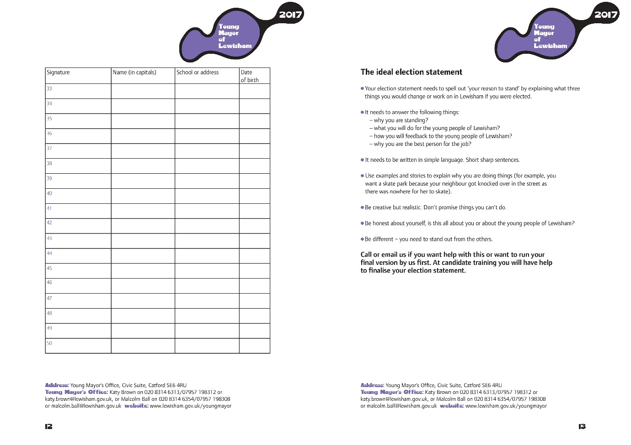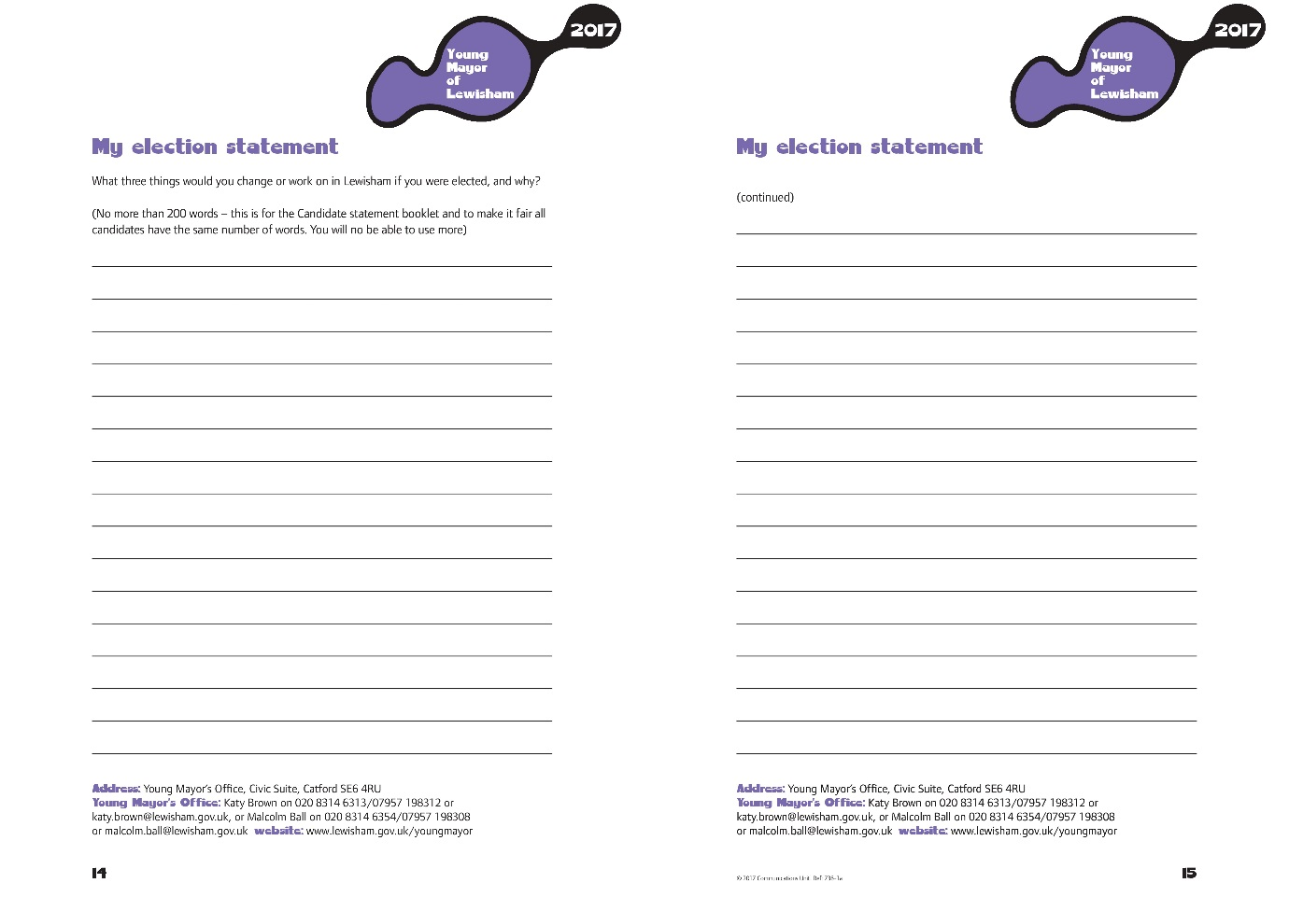

## Appendix 5: Guidance for schools by Helena Pugh, Electoral Services C:\Users\kbrown\AppData\Local\Microsoft\Windows\Temporary Internet Files\Content.Word\page-1.jpgC:\Users\kbrown\AppData\Local\Microsoft\Windows\Temporary Internet Files\Content.Word\page-2.jpgC:\Users\kbrown\AppData\Local\Microsoft\Windows\Temporary Internet Files\Content.Word\page-3.jpgC:\Users\kbrown\AppData\Local\Microsoft\Windows\Temporary Internet Files\Content.Word\page-4.jpgC:\Users\kbrown\AppData\Local\Microsoft\Windows\Temporary Internet Files\Content.Word\page-5.jpgC:\Users\kbrown\AppData\Local\Microsoft\Windows\Temporary Internet Files\Content.Word\page-6.jpg